Website Documentation

Chosen brand: Hanwei, a brand that makes and sells Japanese, Chinese, and European swords.

Website Specifications/Needs:

- The website aims to sell various swords and supplementary products related to swords. It will aim to sell them internationally.

- The target audience will be martial arts practitioners, collectors, and people who want swords for decorative reasons. The age demographic is anyone from the age of 18 and upwards who are able to make online transactions.

- The site needs to have a clean, sharp, and minimalist design to match the qualities of the swords. There need to be categories for each of the three types of swords, as well as any other things like a buying guide or options for supplementary products and training weapons. The products need to have all their specifications shown, such as the type of steel used, blade length, weight, etc. There need to be high quality photos to showcase the swords, including various angles and close-ups.

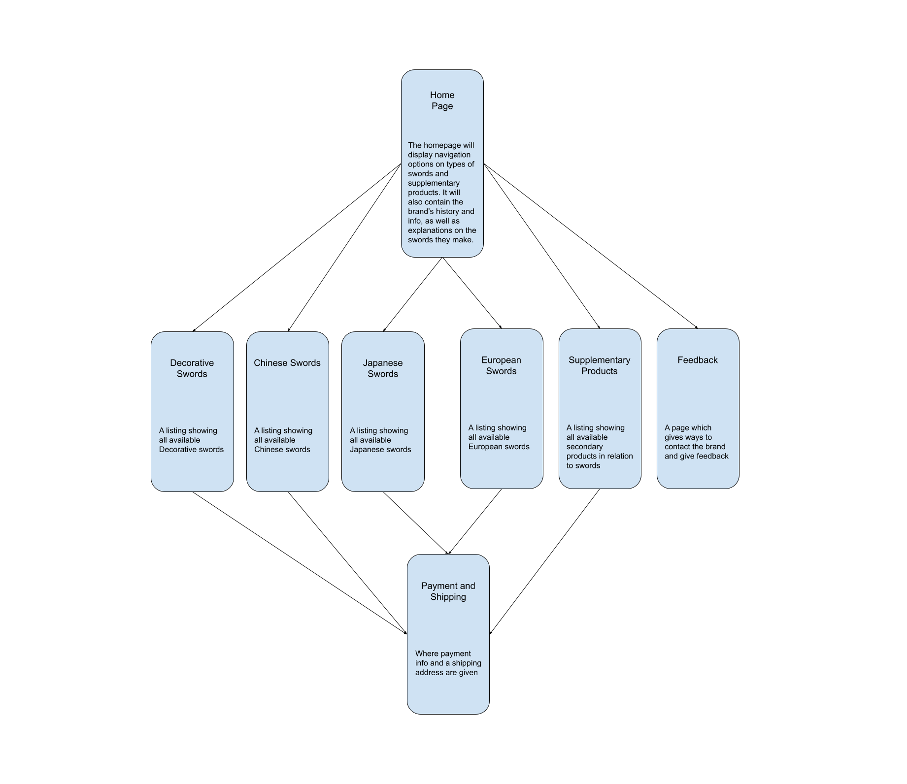
Information Design & Taxonomy:
Technical Brief:

- Visual Studio Code
- Live Server Preview
- Photoshop
- Bootstrap

